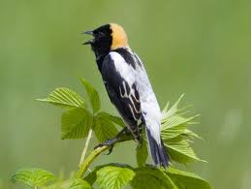
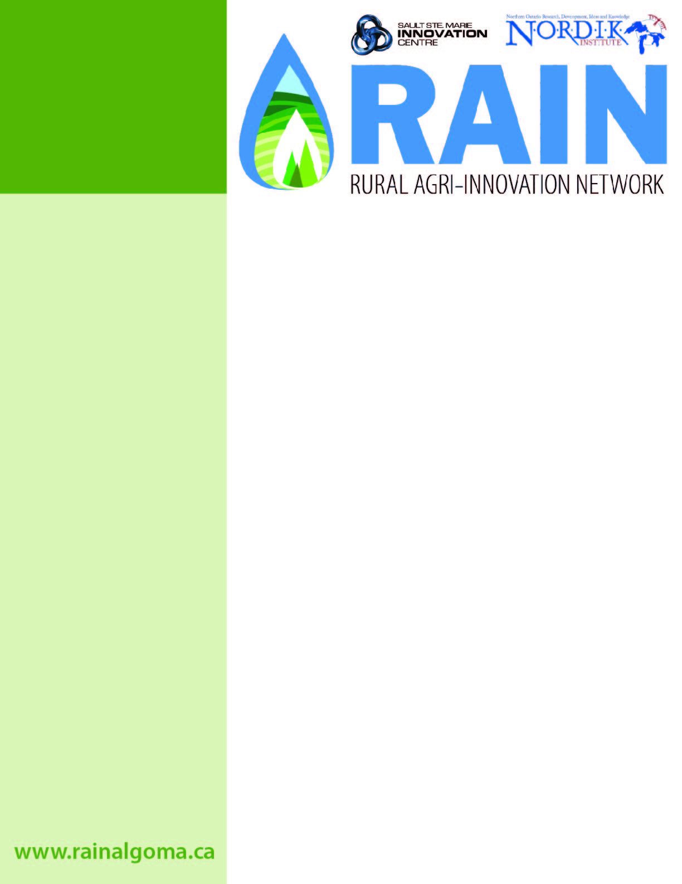
For more information on this project, please contact:
Saul Fraleigh
Agriculture Researcher
Email: sfraleigh@ssmic.com
Phone: 705-942-7927 x3034
Introduction
In partnership with Ontario Ministry of Agriculture Food & Rural Affairs this project was focused on forage quality and bobolink habitat. Bobolink is a threatened species under Ontario's Endangered Species Act whose habitat consists of native grasslands. The project determined nutritional content (including digestible energy) of forage cut late May through late August to assess on-farm harvest management options for bobolink and eastern meadowlark habitat. This project was part of a larger provincial initiative which included samples form 16 different sites across Ontario.
Ministry of Natural Resources Recovery Strategy
Recovery of the Bobolink and Eastern Meadowlark in Ontario poses a significant conservation challenge. The majority of their breeding populations occur on private lands managed by farmers for the production of agricultural goods and services. Given the well-documented, ongoing decline in the extent of pasture and in cattle numbers, coupled with similar declines in the area of hay dominated by grass, a challenge will be to slow the loss of agricultural grasslands in the face of market forces.
The long-term recovery goal is to maintain stable, self-sustaining populations of Bobolinks and Eastern Meadowlarks in Ontario, and in so doing contribute to the conservation of the guild of grassland birds. In the short term (over the 10-year period from 2013-2023), the goal is to slow the annual rate of population decline for both species to an average of no more than 1 percent per year (i.e., no more than 10% over 10 years). Achieving population stability at roughly 90 percent of the present-day population size is the long-term goal thereafter.

Determining Forage Nutrient Content by Date of Cutting – Bobolink Hay Project
RAIN Research Project Update
SUMMARY
In partnership with Ontario Ministry of Agriculture Food & Rural Affairs this project was focused on forage quality and Bobolink (locally known as Skunk Bird) habitat.
North American Breeding Bird Survey data for period 1968 to 2008 indicate a significant decline of 5.2% per year in Canada or a loss of 88% of the population during the last 40 years. Over the most recent 10-year period (1998 to 2008), the survey data shows a significant decline of 4.6% per year, which corresponds to a population decline of 38% over this period.
Delayed hay cutting has been proposed as a viable option to mitigate population losses, but may come at the expense of decreased forage nutritional value.
Sampling and Lab Analysis
Over the 2014 and 2015 growing season, RAIN researchers collected samples from a typical hay field in the Echo Bay area on a weekly basis. These samples were labelled and frozen stored until the end of the season, at which time were shipped for lab analysis. Lab analysis was thorough and included dry weight, non-digestible fibre (NDF), acid detergent fibre (ADF), crude protein (CP), starch, fat, macro and micro minerals as well as sugars.
Project Results
As expected, crude protein declined through the growing season with a significant drop in mid-July. This correlates with decreases in NDF and ADF, clearly showing the loss of nutritional value the later hay is left on field. Forage dry matter (DM) increases through the season peaking in late July while nutrient content decreases. It is clear from previous research and through this trial that the earlier hay is cut, the greater nutritional value will be in your forage. Although harvest quantity is reduced, gains in feed value may make up for lost volume. Other studies have documented bobolink rate of fledglings based on variable delays in cutting regimes. Nocera et al. (2005) found that a one week delay in cutting time (post-July 1) increased fledgling rate of bobolink form 0-20% while a delay of two weeks allowed maximum fledging rates. Crude protein losses were 2.1% and 3.5% for one and two week delays, respectively.
www.rainalgoma.ca
Opportunities and Threats for Algoma Farmers
As more and more wildlife are added to the Species at Risk and Endangered Species lists, Algoma land managers will be affected. These could be positive, such as an incentive programs which would pay landowners for the environmental services they are providing, or affects could be negative such as regulations regarding the time of year hay can be cut. Other advantages to preserve Bobolink breeding habitat include a reduced populations of potentially harmful insects like caterpillars, weevils, cutworms, beetles, and flies for which these birds feed on. Those farmers who require high quality hay for their operations will have considerably fewer options. For growing livestock and nursing mothers it is essential to provide highly nutritional feed in order to maintain body condition and negate weight losses. Compensation for delayed harvesting would come at a much higher cost to stocker and dairy operations.
Reports from Algoma farmers verify the presence and high abundance of Bobolink in the region. This is a result of our large production of hay and forage for cattle, equine and small ruminants. Further, there are many abandoned fields and natural habitat in the area, providing ideal nesting locations for these grassland birds. When looked at from a regional perspective, Algoma currently acts as a sanctuary for this endangered species, but there is always room for improvement. Besides the delay in cutting regime for hay farmers, practicing management-intensive grazing for pastured cattle can greatly improve Bobolink habitat as compared to continuous grazing. Rotational grazing allows rest and recovery of forages enabling increased sward height for nest protection. Further, new technology such as infrared video cameras mounted to unmanned aerial vehicles can quickly fly over a field and detect heat signatures from breeding birds. This information could assist farmers in specific cutting paths and potentially discern nesting location patterns (such as proximity to forest edge or fence lines).
References:
Nocera, J.J., Parsons, G.J., Milton, G.R., Fredeen A.H., 2005. Compatinility of delayed cutting regime with bird breeding and hay nutritional quality. Agriculture, Ecocsystems and Environment. 107, 245-253.

